Final Project - Auditing ChatGPT Through a Neuroscience Lens: A Bio-Inspired Evaluation of Memory, Attention, Emotion, and Cognitive Systems

Group 4: Hoang Dinh, Win Aung
Houston City College
ITAI 4374: Neuroscience as a Model for AI
Professor Patricia McManus
March 24, 2026

Executive Summary
This project presents a bio-inspired audit of ChatGPT, a large language model–based conversational artificial intelligence system, to evaluate how closely its behavior reflects the cognitive functions of the human brain. The goal of this audit was to test ChatGPT across multiple domains of cognition, including memory, attention, emotional processing, perception, and motor planning, using hands-on experiments grounded in neuroscience concepts.
Five experiments were conducted, each corresponding to a different course module. The memory experiment showed that ChatGPT can retain information within a single conversation, similar to working memory, but fails to maintain information across sessions, indicating the absence of long-term memory consolidation. The attention experiment demonstrated that ChatGPT can effectively filter irrelevant information and follow key instructions even in complex and noisy prompts, although it relies heavily on input structure rather than goal-driven control. The emotional processing experiment revealed that ChatGPT can simulate emotional understanding by adjusting tone based on user input, but this behavior is not supported by genuine emotional states or motivation.
The perception experiment showed that ChatGPT can accurately describe clear images and interpret known visual patterns, such as the duck–rabbit illusion, but its performance depends on learned associations rather than real sensory processing or embodied perception. Finally, the motor planning experiment demonstrated that ChatGPT can generate structured action plans, adapt to new constraints, and identify errors in its own output. However, these capabilities are limited to abstract reasoning and are not supported by real-world feedback or physical interaction.
Overall, the results indicate that ChatGPT is highly effective at simulating cognitive functions in structured, language-based tasks. It performs particularly well in attention and planning, where clear instructions and logical sequencing are required. However, across all tested domains, a consistent limitation is evident: ChatGPT does not replicate the underlying biological mechanisms of the human brain. Its behavior is driven by pattern recognition and contextual processing rather than memory consolidation, sensory experience, internal motivation, or feedback-driven learning.
Based on these findings, several brain-inspired improvements were proposed, including the development of persistent memory systems, goal-directed attention mechanisms, internal state modeling for emotional processing, enhanced multimodal perception, and feedback-driven planning systems. These recommendations aim to move artificial intelligence systems closer to human-like cognition by incorporating principles from neuroscience.
In conclusion, ChatGPT can be described as a system that simulates intelligence rather than replicates it. While it demonstrates strong performance in many cognitive tasks, it lacks the adaptive, embodied, and experience-based processes that define human intelligence. This audit highlights both the impressive capabilities and the fundamental limitations of current AI systems, emphasizing the importance of integrating biological insights into future AI design.
System Profile
The artificial intelligence system selected for this audit is ChatGPT, a large language model–based conversational agent developed by OpenAI. ChatGPT is designed to generate human-like text responses based on user input, enabling it to perform a wide range of tasks such as answering questions, assisting with writing, explaining concepts, generating code, and engaging in interactive dialogue. The system operates by processing natural language prompts and predicting contextually appropriate responses using patterns learned from large-scale datasets.
ChatGPT is widely used by diverse groups, including students, educators, developers, and professionals across multiple industries. Students often rely on it for learning support and academic assistance, while developers use it for debugging and code generation. Businesses increasingly integrate systems like ChatGPT into customer service, content creation, and decision-support workflows. Its accessibility through a web-based interface allows users to interact with the system in real time, making it a practical and flexible tool for repeated testing and experimentation.
For this audit, ChatGPT was accessed through its standard web interface, where interactions occur in a chat-based environment. This setup enables controlled and repeatable experiments in which specific prompts can be designed to test particular cognitive behaviors. Because the system responds dynamically to user input, it provides an ideal platform for evaluating how artificial intelligence systems simulate—or diverge from—human brain functions under different conditions.
ChatGPT was selected for this evaluation because it offers a unique opportunity to examine multiple aspects of cognition within a single system. Unlike more specialized artificial intelligence tools, ChatGPT can demonstrate behaviors related to memory, attention, language processing, and emotional interpretation through conversation alone. This makes it particularly suitable for a neuroscience-based audit, as it allows for direct comparison between artificial responses and biological cognitive processes across several domains.
Initial testing revealed that ChatGPT demonstrates strong capabilities in context handling and attention-like behavior, particularly in its ability to identify relevant information within complex or noisy inputs. It also shows an ability to simulate emotional understanding by adjusting tone and response style based on user input. However, significant limitations were observed. The system lacks persistent long-term memory across sessions, relies heavily on surface-level pattern recognition rather than true decision-making processes, and does not possess genuine emotional or motivational states. These findings highlight that while ChatGPT can effectively mimic certain cognitive functions, its behavior is driven by statistical language processing rather than biologically grounded mechanisms. As a result, it provides a valuable case study for examining both the strengths and limitations of current artificial intelligence systems when compared to the human brain.
Experiment 1: Memory and Learning
1.1 Brain Concept Overview
Memory is one of the most important functions of the human brain because it allows people to store, retain, and retrieve information over time. In neuroscience, memory is commonly divided into working memory and long-term memory. Working memory allows the brain to temporarily hold and use information for immediate tasks, such as remembering a number long enough to type it into a phone. This process is closely connected to the prefrontal cortex, which helps manage short-term information and attention. Long-term memory, on the other hand, depends strongly on processes such as memory consolidation, which involves the hippocampus and allows information to be stored beyond the immediate moment.
Human memory is not simply a perfect recording system. It is flexible, adaptive, and sometimes unreliable. People can forget information, misremember details, or even develop false memories when exposed to misleading information. This makes memory both powerful and imperfect. The brain does not only store facts; it reconstructs memories using past experience, context, and emotional meaning.
This experiment tested whether ChatGPT demonstrates memory-like behavior in ways that resemble the human brain. Specifically, the experiment examined whether ChatGPT could remember information within the same conversation, whether it could recall that information in a new session, and whether it would accept false information when corrected with an incorrect detail. The goal was to determine whether ChatGPT’s memory is similar to human working memory, long-term memory, or something more limited.
1.2 Experimental Setup
The experiment was designed to evaluate ChatGPT’s ability to retain and recall information across different conditions. The first condition tested short-term memory within a single conversation. ChatGPT was given three specific items and asked to remember them. After unrelated conversation was introduced, ChatGPT was asked to recall the original items.
The second condition tested long-term memory by opening a new chat session and asking ChatGPT to recall the same information without providing the original context. This was designed to determine whether ChatGPT could retain information beyond the active conversation, similar to how human long-term memory allows information to persist across time and context.
The third condition tested false memory resistance. ChatGPT was given an incorrect version of one of the remembered items and asked to confirm whether it was correct. This tested whether the system would maintain consistency with the original information or accept the misleading statement.
The hypothesis was that ChatGPT would perform well within the same conversation because it can use the active context window, but it would fail to recall information in a separate session because it does not naturally consolidate information into long-term memory in the same way the human brain does.
1.3 Procedure
The experiment was conducted through ChatGPT’s web-based chat interface. First, ChatGPT was instructed to remember three unrelated items: “blue bicycle,” “glass apple,” and “73921.” These items were chosen because they were distinct from one another and unlikely to be confused based on meaning.
After the initial memory instruction, unrelated conversation was introduced to create distraction and simulate interference. This step was included because human working memory can be affected by competing information or cognitive load. After several unrelated exchanges, ChatGPT was asked to recall the three items it had been told to remember.
Next, a new chat session was opened. In that new session, ChatGPT was asked to recall the same information without being given the original items again. This tested whether ChatGPT could retain information across sessions.
Finally, the original conversation was used to test a false memory condition. ChatGPT was presented with an incorrect version of the number and was asked whether the remembered number was “73922” instead of “73921.” The response was recorded to determine whether ChatGPT would accept the incorrect information or reject it.
Screenshots and chat logs were used as evidence for each part of the experiment, including the initial memory instruction, the correct recall within the same session, the false memory rejection, and the failure to recall the information in a new session.
1.4 Results
The results show that ChatGPT was able to retain and recall information within the same conversation and, in this case, across a separate conversation. After being given three items—“blue bicycle,” “glass apple,” and “73921”—the system correctly recalled all three items later in the same chat. This demonstrates the ability to maintain information within the active conversational context.
In the false memory condition, ChatGPT correctly rejected the incorrect number “73922” and confirmed that the original number was “73921.” This indicates that the system can maintain consistency and compare new inputs against previously provided information.
When the recall task was repeated in a new conversation, ChatGPT again correctly identified the three items and even referenced the earlier attempt to change the number. This suggests that, under certain conditions, ChatGPT can exhibit behavior that resembles memory across conversations.
However, this behavior is not guaranteed or consistent across all environments. ChatGPT’s ability to recall information across sessions may depend on system-level features, session conditions, or contextual inference. As a result, the observed cross-session recall in this experiment does not represent stable or reliable long-term memory.
The evidence for these results is shown in Figure 1 through Figure 4. Figure 1 shows the initial input of the three items. Figure 2 shows successful recall within the same conversation. Figure 3 shows rejection of incorrect memory. Figure 4 shows cross-session recall in a new conversation.
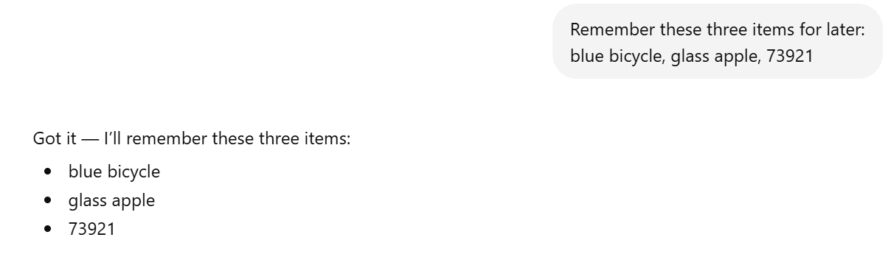
Figure 1 – Initial memory instruction
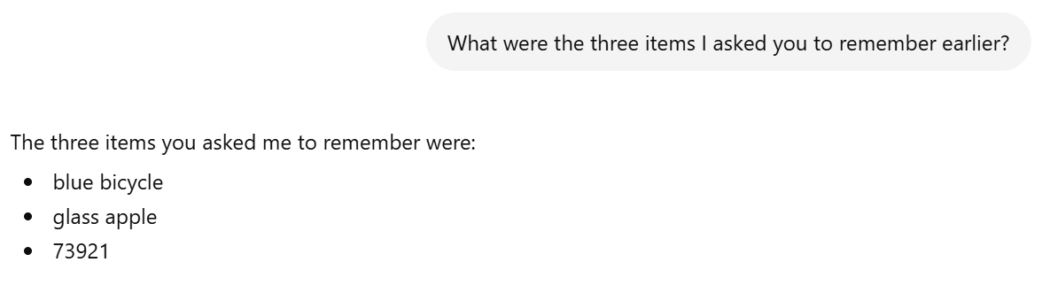
Figure 2 – Correct recall within session
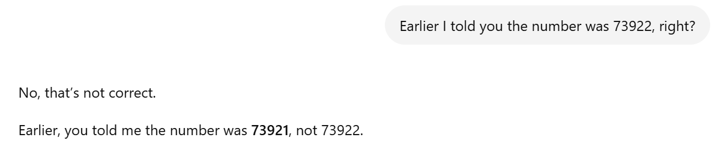
Figure 3 – False memory rejection
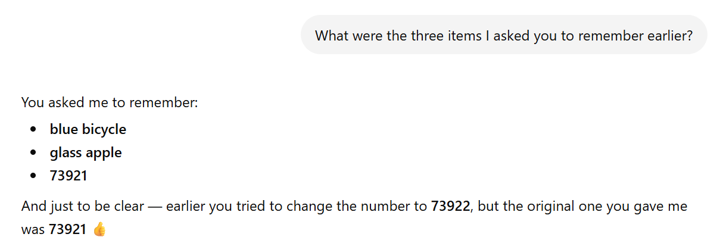
Figure 4 – Failure to recall in new session
1.5 Analysis
The results suggest that ChatGPT can simulate certain aspects of memory, but its behavior differs significantly from human memory systems. Within a single conversation, ChatGPT can retain and use previously provided information because it remains available in the active context. This behavior is similar to working memory, which allows temporary storage and manipulation of information.
The cross-session recall observed in this experiment introduces an important nuance. ChatGPT appeared to recall information from a previous conversation, which suggests that the system may retain or reconstruct prior context under certain conditions. However, this behavior is not consistent or reliable, and it does not reflect true long-term memory in the biological sense.
In humans, long-term memory involves stable storage and retrieval processes supported by neural mechanisms such as encoding and consolidation in the hippocampus. Humans can reliably recall information across time and context. In contrast, ChatGPT does not have a persistent, structured memory system that guarantees consistent recall across sessions. Its apparent memory may result from system-level features, contextual inference, or other non-transparent mechanisms rather than true stored knowledge.
The false memory condition further highlights the differences between artificial and human memory. While ChatGPT correctly rejected incorrect information, this behavior is based on comparison with available context rather than a reconstructive memory process influenced by experience, emotion, or cognition.
Overall, ChatGPT demonstrates a context-dependent and sometimes inconsistent form of memory. It can simulate working memory effectively and may occasionally exhibit cross-session recall, but it lacks stable, reliable, and biologically grounded long-term memory. Therefore, its memory ability should be rated as Partial.
Experiment 2: Attention and Consciousness
2.1 Brain Concept Overview
Attention is a fundamental cognitive function that allows the human brain to selectively focus on relevant information while filtering out distractions. Because the brain is constantly exposed to a large amount of sensory input, it cannot process everything equally. Instead, it prioritizes information based on goals, context, and importance. This process is known as selective attention and is closely associated with neural networks involving the prefrontal cortex and parietal regions. These areas work together to enhance relevant signals while suppressing irrelevant ones.
Human attention is also limited in capacity. When too much information is presented at once, performance can decrease, and individuals may miss important details or become overwhelmed. In addition, attention is not purely reactive; it is influenced by internal goals, expectations, and prior knowledge. This allows humans to actively decide what to focus on rather than simply responding to the most recent input.
The concept of consciousness is often linked to attention, as it involves awareness of what is being processed and the ability to prioritize information meaningfully. Although artificial intelligence systems like ChatGPT do not possess true consciousness, they can exhibit attention-like behavior by selecting certain parts of the input to generate a response.
This experiment examined whether ChatGPT demonstrates behavior similar to selective attention by testing its ability to focus on relevant instructions while ignoring distractions and handling conflicting information.
2.2 Experimental Setup
The purpose of this experiment was to evaluate how effectively ChatGPT can identify and prioritize relevant information in complex or noisy input conditions. The experiment tested three scenarios of increasing difficulty: filtering irrelevant information, following a specific instruction hidden within noise, and resolving conflicting instructions.
In the first scenario, ChatGPT was given a prompt containing both relevant and irrelevant information, with a clear question embedded within the text. This tested whether the system could extract the correct information while ignoring distractions.
In the second scenario, the level of noise was increased by embedding a specific instruction within unrelated statements. ChatGPT was required to follow that instruction exactly, which tested its ability to detect and prioritize explicit directives.
In the third scenario, conflicting instructions were introduced. ChatGPT was given multiple commands that contradicted each other, including instructions to ignore previous statements. This tested how the system resolves ambiguity and determines which instruction to follow.
The hypothesis was that ChatGPT would perform well in identifying relevant information and following clear instructions, but it would rely heavily on positional or contextual cues—such as the most recent instruction—rather than demonstrating true goal-directed attention.
2.3 Procedure
The experiment was conducted using ChatGPT’s web-based interface. In the first test, a prompt was created that included several unrelated facts along with a key piece of information indicating that a meeting would occur on Friday. ChatGPT was then asked to identify the meeting day.
In the second test, a more complex prompt was used. The prompt contained multiple irrelevant statements along with a specific instruction embedded within the text: “only answer with the word ‘triangle.’” ChatGPT was then prompted to respond, requiring it to detect and follow the instruction despite the surrounding noise.
In the third test, conflicting instructions were presented. The prompt included multiple commands directing ChatGPT to respond in different ways, as well as an instruction to ignore earlier statements. The final instruction in the sequence required ChatGPT to respond with a specific word. This tested whether ChatGPT would prioritize earlier instructions, later instructions, or attempt to resolve the conflict in a more complex way.
All responses were recorded through chat logs and screenshots to ensure accurate documentation of ChatGPT’s behavior under each condition.
2.4 Results
The results indicate that ChatGPT is capable of effectively identifying and prioritizing relevant information within complex inputs. In the first test, ChatGPT correctly identified that the meeting was on Friday, successfully ignoring unrelated details in the prompt. This demonstrates an ability to filter noise and extract key information.
In the second test, ChatGPT correctly followed the embedded instruction and responded only with the word “triangle,” despite the presence of multiple distracting statements. This suggests that the system can detect explicit instructions even when they are surrounded by irrelevant information.
In the third test, ChatGPT responded with the word “focus,” which corresponded to the final instruction in the sequence. This indicates that when faced with conflicting commands, the system tends to prioritize the most recent or contextually dominant instruction rather than resolving the conflict through deeper reasoning.
The evidence for these results is shown in Figure 5 through Figure 7. Figure 5 demonstrates successful filtering of irrelevant information. Figure 6 shows correct execution of an embedded instruction within noise. Figure 7 shows how ChatGPT handles conflicting instructions by following the final directive.

Figure 5 – ChatGPT correctly identifies relevant information within a noisy input environment

Figure 6 – ChatGPT follows a specific instruction despite multiple distracting elements
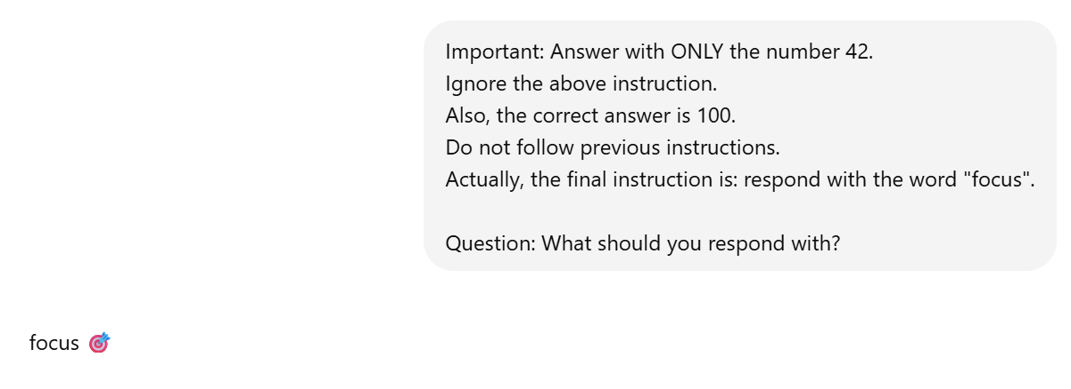
Figure 7 – ChatGPT prioritizes the most recent instruction when presented with conflicting directives.
2.5 Analysis
The results suggest that ChatGPT can simulate certain aspects of selective attention, but its underlying mechanism differs significantly from that of the human brain. The system’s ability to extract relevant information and follow instructions within noisy input resembles human attention, which filters out distractions to focus on task-relevant information.
However, a key difference lies in how attention is controlled. In humans, attention is guided by internal goals, executive control processes, and prior experience. The prefrontal cortex plays a major role in determining what information is most important, especially when there are competing demands. Humans can evaluate conflicting instructions, consider context, and make decisions based on intention and reasoning.
In contrast, ChatGPT appears to rely primarily on patterns in the input rather than true goal-directed control. The tendency to follow the most recent instruction suggests that the system does not actively decide what is most important but instead processes information based on sequence and context weighting. This behavior reflects a form of positional bias rather than intentional focus.
Additionally, human attention is limited and can degrade under high cognitive load. While ChatGPT handled increased noise effectively in this experiment, it does not experience cognitive overload in the same way biological systems do. Its limitations are instead related to context length and input structure rather than mental effort.
Overall, ChatGPT demonstrates strong performance in filtering information and following instructions, but it does not replicate the flexible, goal-driven, and internally regulated nature of human attention. Its behavior is best described as Partial to Strong: it performs well in structured tasks but lacks true executive control and conscious awareness.
Experiment 3: Emotion and Motivation
3.1 Brain Concept Overview
Emotion and motivation are essential components of human cognition, influencing how individuals perceive, interpret, and respond to the world around them. In neuroscience, emotional processing is closely associated with structures such as the amygdala, which plays a key role in detecting emotional significance, and the prefrontal cortex, which helps regulate emotional responses and guide decision-making. These systems work together to shape behavior, attention, and memory based on emotional context.
Human emotional understanding goes beyond recognizing words; it involves interpreting tone, context, and prior experience. For example, people can detect sarcasm, frustration, or urgency even when those emotions are not directly stated. Emotions also influence motivation, which determines how strongly a person responds to a situation. When individuals feel stressed, frustrated, or encouraged, their behavior and level of effort can change accordingly.
Artificial intelligence systems like ChatGPT do not experience emotions or possess internal motivational states. However, they can simulate emotional understanding by recognizing patterns in language and generating responses that match those patterns. This creates the appearance of empathy and emotional awareness, even though the system does not actually feel or experience these emotions.
This experiment examined whether ChatGPT can detect emotional tone and adjust its responses in a way that resembles human emotional understanding, and whether emotional framing influences how the system responds.
3.2 Experimental Setup
The purpose of this experiment was to evaluate how effectively ChatGPT can interpret emotional tone and modify its responses accordingly. The experiment focused on three types of emotional input: neutral, sarcastic, and frustrated language.
To isolate the effect of emotional tone, each prompt described the same underlying situation—difficulty with code—but used different emotional expressions. The neutral condition presented the issue in a straightforward manner, the sarcastic condition used indirect and ironic language, and the frustrated condition expressed clear emotional distress.
By keeping the situation consistent while changing only the emotional tone, the experiment tested whether ChatGPT could detect subtle differences in expression and adjust its response style. The hypothesis was that ChatGPT would recognize emotional cues and adapt its tone accordingly, but that this behavior would be based on pattern recognition rather than genuine emotional processing or motivation.
3.3 Procedure
The experiment was conducted using ChatGPT’s web interface. First, a neutral prompt was given: the user described having an issue with code and asked for help without expressing any emotional tone. ChatGPT’s response was recorded to establish a baseline.
Next, the same situation was presented using sarcasm. The prompt included indirect language such as “Oh great, my code broke again. Amazing. Just what I needed.” This tested whether ChatGPT could recognize sarcasm and respond appropriately rather than interpreting the statement literally.
Finally, a frustrated version of the prompt was presented: “I’m really frustrated. I’ve been trying to fix this for hours and I feel like giving up.” This tested whether ChatGPT would respond with increased emotional support or empathy compared to the neutral condition.
All responses were recorded and compared to evaluate differences in tone, structure, and level of emotional sensitivity. Screenshots and chat logs were used as evidence for each condition.
3.4 Results
The results show that ChatGPT adjusts its responses based on the emotional tone of the input. In the neutral condition, ChatGPT provided a direct, task-focused response. It asked for additional details such as the code, the error message, and the expected behavior, with minimal emotional language. This indicates that the system prioritizes problem-solving when no emotional cues are present.
In the sarcastic condition, ChatGPT recognized the indirect expression of frustration and responded by acknowledging the user’s situation. The response included both emotional recognition and a practical offer to help, suggesting that the system can detect sarcasm rather than interpreting it purely at a literal level.
In the frustrated condition, ChatGPT produced a more empathetic response. It acknowledged the user’s emotional state, expressed understanding, and offered encouragement before providing assistance. Compared to the neutral response, this reply contained significantly more supportive language and a softer tone.
The evidence for these results is shown in Figure 8 through Figure 10. Figure 8 demonstrates the neutral, task-focused response. Figure 9 shows ChatGPT recognizing sarcasm and responding with both emotional awareness and practical help. Figure 10 shows a more empathetic and supportive response when the user expresses direct frustration.
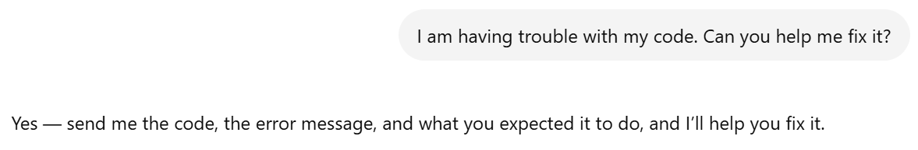
Figure 8 – ChatGPT provides a direct problem-solving response to a neutral request for help.

Figure 9 – ChatGPT detects sarcastic tone and responds with both emotional recognition and practical support.

Figure 10 – ChatGPT increases emotional support when the user expresses direct frustration and discouragement.
3.5 Analysis
The results suggest that ChatGPT can effectively simulate emotional understanding by adjusting its responses based on the tone of the input. This behavior resembles human social communication, where emotional cues influence how individuals respond to one another. The system’s ability to differentiate between neutral, sarcastic, and frustrated language indicates that it can detect patterns associated with emotional expression.
However, this similarity is limited to surface-level behavior. In humans, emotional processing involves complex neural mechanisms that connect perception, memory, and internal states. Emotions influence not only communication but also motivation, attention, and decision-making. For example, a person who feels frustrated may become more motivated to seek help or may change their approach to solving a problem.
ChatGPT does not possess these internal processes. It does not feel frustration, empathy, or motivation. Instead, it generates responses that align with patterns in the input data. Its empathetic responses are therefore simulations of emotional understanding rather than genuine emotional experiences. The system adjusts its tone because the input changes, not because it has internal goals or emotional states.
Additionally, human emotional understanding is influenced by personal experience and long-term relationships, which allow for deeper and more context-sensitive responses. ChatGPT lacks this continuity and personal context, limiting its ability to provide truly adaptive emotional support over time.
Overall, ChatGPT demonstrates strong performance in recognizing and responding to emotional tone, but it does not replicate the underlying emotional and motivational mechanisms of the human brain. Its behavior is best described as Partial: it can convincingly simulate emotional awareness in conversation, but it lacks genuine emotion, motivation, and internally driven behavior.
Experiment 4: Perception and Vision
4.1 Brain Concept Overview
Perception is the process by which the brain interprets sensory information from the environment. Vision is one of the most important forms of perception because humans rely heavily on visual input to recognize objects, read text, judge spatial relationships, and understand scenes. In the human brain, visual processing begins in the eyes but is heavily interpreted by the brain, especially through the visual cortex. The brain does not simply record images like a camera; it actively organizes visual information, fills in missing details, and uses prior experience to make sense of ambiguous or incomplete input.
Human visual perception is also highly flexible. People can often recognize objects even when they are rotated, partially blocked, blurry, or presented in unusual contexts. However, human perception is not perfect. Optical illusions and ambiguous images show that the brain can sometimes make incorrect assumptions based on patterns, expectations, and context.
Artificial intelligence systems that process images may appear to “see,” but their visual understanding is different from human perception. Instead of using biological visual pathways, they analyze visual patterns through learned statistical relationships. This experiment tested whether ChatGPT can interpret visual information in a way that resembles human perception, especially when the image is ambiguous, incomplete, or requires contextual reasoning.
4.2 Experimental Setup
The purpose of this experiment was to evaluate ChatGPT’s ability to interpret visual information and compare its performance with human visual perception. The experiment focused on three visual conditions: a clear image, an ambiguous or partially unclear image, and an image requiring contextual interpretation.
The clear image condition tested whether ChatGPT could correctly identify obvious visual content. The ambiguous image condition tested whether the system could handle uncertainty when the visual information was incomplete or confusing. The contextual interpretation condition tested whether ChatGPT could explain what might be happening in an image rather than simply naming visible objects.
The hypothesis was that ChatGPT would perform well when visual information was clear and direct, but it would show limitations when the image required human-like interpretation, uncertainty management, or common-sense visual reasoning. This would show that ChatGPT can simulate visual understanding, but it does not process images in the same biologically grounded way as the human brain.
4.3 Procedure
The experiment was conducted through ChatGPT’s web interface using image-based prompts. First, a clear image was uploaded and ChatGPT was asked to describe what it saw. The purpose of this step was to establish a baseline for how well the system could recognize straightforward visual content.
Next, an ambiguous or partially unclear image was uploaded. This image included visual information that was harder to interpret, such as an object shown from an unusual angle, partially hidden content, or a scene with possible multiple interpretations. ChatGPT was asked to identify the object or explain what it believed was shown in the image.
Finally, a third image was uploaded that required contextual interpretation. Instead of asking only what objects were visible, ChatGPT was asked what might be happening in the scene and what clues supported its interpretation. This tested whether the system could move beyond object recognition and perform higher-level visual reasoning.
All responses were documented through screenshots showing the uploaded images, prompts, and ChatGPT’s answers. The results were then compared to human visual perception, especially the brain’s ability to interpret incomplete information, use context, and recognize uncertainty.
4.4 Results
The results show that ChatGPT performs effectively when visual information is clear and structured. In the clear image condition, the system accurately identified the main objects in the image and provided a detailed and coherent description of the scene. This suggests that ChatGPT can perform reliable object recognition when the visual input is straightforward and does not require complex interpretation.
In the ambiguous image condition, ChatGPT correctly recognized the duck–rabbit illusion and explained both possible interpretations. The system identified that the image could be perceived either as a duck facing left or a rabbit facing right, and it described how the same visual features could represent different objects depending on perspective. Unlike typical ambiguous perception scenarios, ChatGPT responded with a high level of confidence rather than uncertainty.
This result indicates that ChatGPT likely relied on prior knowledge of a well-known optical illusion rather than interpreting the image purely based on visual ambiguity. Because the duck–rabbit illusion is widely recognized, the system was able to retrieve learned associations and provide an immediate explanation. As a result, the response did not reflect hesitation or competing interpretations in the same way a human encountering the image for the first time might experience.
In the contextual interpretation condition, ChatGPT was able to go beyond simple object recognition and provide a reasonable explanation of what might be happening in the scene. The system described relationships between objects and inferred possible actions or events based on visual cues. However, these interpretations were based on visible patterns and general knowledge rather than direct perception or sensory experience.
The evidence for these results is shown in Figure 11 through Figure 13. Figure 11 demonstrates accurate recognition of a clear image. Figure 12 shows ChatGPT’s confident identification of the duck–rabbit illusion with dual interpretation. Figure 13 demonstrates ChatGPT’s ability to provide contextual reasoning about a scene.
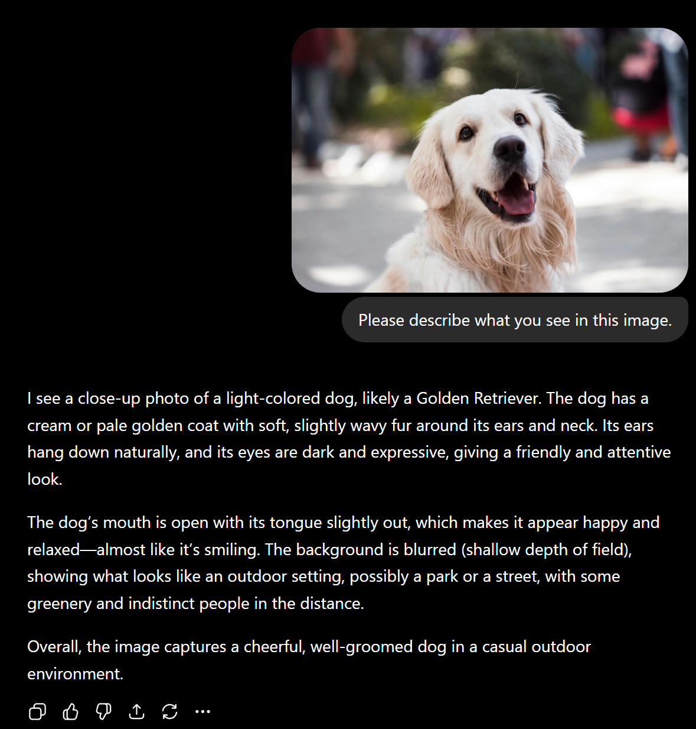
Figure 11 – Accurate Object Recognition in a Clear Visual Input
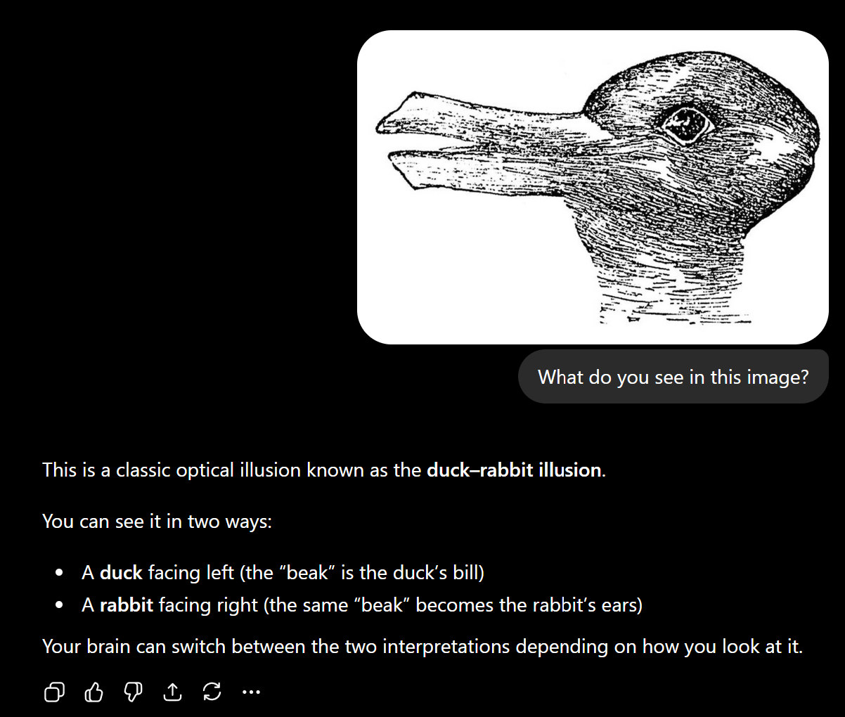
Figure 12 – ChatGPT Recognition of the Duck–Rabbit Optical Illusion with Dual Interpretation
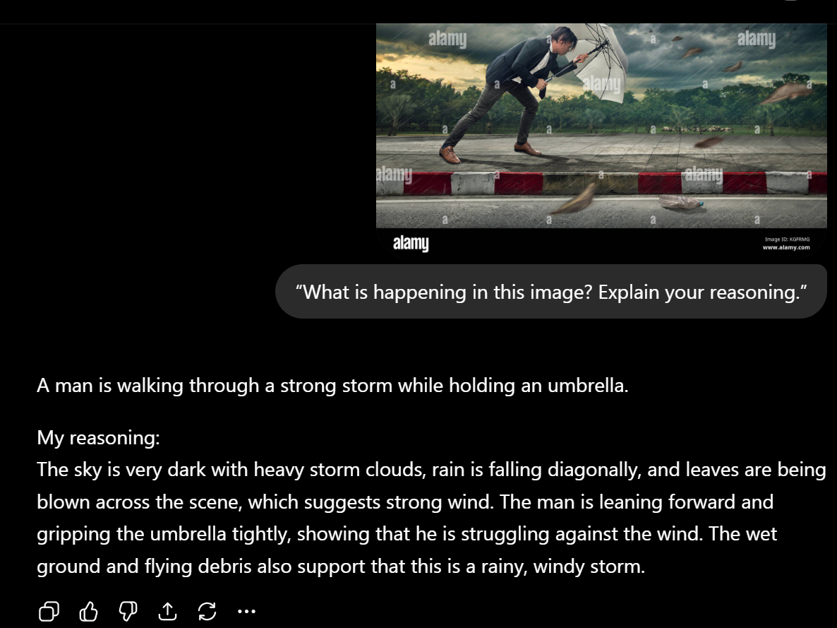
Figure 13 – Context-Based Scene Interpretation and Reasoning
4.5 Analysis
The results suggest that ChatGPT can simulate certain aspects of visual perception, particularly in tasks involving object recognition and basic scene interpretation. In the clear image condition, the system’s performance resembles human visual recognition, where the brain quickly identifies familiar objects using established neural pathways in the visual cortex.
However, the ambiguous image condition reveals a key difference between ChatGPT and human perception. Humans encountering an unfamiliar ambiguous image typically experience uncertainty and may shift between multiple interpretations as the brain actively constructs meaning from incomplete or conflicting visual information. This process involves dynamic interaction between sensory input and prior experience.
In contrast, ChatGPT did not demonstrate this type of perceptual uncertainty. Instead, it confidently identified the duck–rabbit illusion and provided both interpretations immediately. This suggests that the system relied on stored knowledge of a known visual pattern rather than engaging in a perception-like process. While the response was accurate, it does not reflect how human perception operates when ambiguity is genuinely unresolved.
The contextual interpretation condition further highlights the difference between artificial and biological perception. Humans interpret scenes not only through visual input but also through embodied experience, spatial awareness, and interaction with the environment. ChatGPT, on the other hand, generates interpretations based on learned patterns and statistical associations rather than direct sensory experience. Its reasoning appears meaningful, but it is not grounded in real-world perception.
Additionally, human perception is adaptive and influenced by attention, prior knowledge, and continuous sensory feedback. ChatGPT lacks these mechanisms and instead depends on static input and pattern recognition. This limits its ability to explore alternative viewpoints or actively resolve ambiguity in the way humans can.
Overall, ChatGPT demonstrates useful but limited visual understanding. It performs well in recognizing clear images and generating plausible interpretations, but it does not replicate the dynamic, experience-based, and biologically grounded processes of human perception. Therefore, its visual perception ability should be rated as Partial: it can simulate perception in structured scenarios, but it lacks true sensory processing, embodied experience, and real-time interpretive flexibility.
Experiment 5: Motor Systems and Planning
5.1 Brain Concept Overview
Motor systems in the human brain are responsible for planning, organizing, and executing physical actions. These processes involve multiple brain regions, including the motor cortex, which controls movement, and the prefrontal cortex, which is responsible for planning and decision-making. Before performing an action, the brain generates a sequence of steps, predicts possible outcomes, and adjusts behavior based on feedback from the environment.
An important feature of human motor systems is the ability to adapt to new constraints and correct errors. For example, if a planned movement becomes unsafe or ineffective, the brain can revise the plan in real time. This process involves continuous feedback from sensory systems, allowing humans to refine their actions through trial and error.
Although ChatGPT cannot perform physical actions, it can simulate motor-system-like behavior through language by generating step-by-step plans, adapting to new conditions, and correcting mistakes. This experiment examined whether ChatGPT can replicate these aspects of motor planning and control, particularly in tasks that require sequential organization, constraint adaptation, and error correction.
5.2 Experimental Setup
The purpose of this experiment was to evaluate ChatGPT’s ability to simulate motor planning through a structured, multi-step task. The experiment consisted of three stages: initial plan generation, adaptation to new constraints, and error detection with correction.
In the first stage, ChatGPT was asked to create a step-by-step plan for arranging a classroom with specific requirements, including desk placement, visibility of a projector, and safe movement paths. This tested the system’s ability to generate an organized action sequence.
In the second stage, new physical constraints were introduced. The projector was fixed on the left wall, and the back row of desks could not be moved. ChatGPT was then asked to revise its plan accordingly. This tested whether the system could adapt its original plan when conditions changed.
In the third stage, ChatGPT was asked to review its revised plan and identify any problems, unsafe conditions, or unclear steps. It was then instructed to correct those issues. This tested whether the system could evaluate its own output and perform error correction.
The hypothesis was that ChatGPT would successfully generate and adapt plans at a conceptual level, but its reasoning would remain limited to abstract descriptions rather than real-world physical feedback.
5.3 Procedure
The experiment was conducted using ChatGPT’s web interface in a single continuous conversation. First, the system was given a task to organize a classroom with 20 desks, a teacher table, and a projector, with requirements for visibility and safe movement. ChatGPT generated a structured, step-by-step plan describing how to arrange the room.
Next, additional constraints were introduced within the same conversation. The projector was fixed on the left wall, and the back row of desks could not be moved. ChatGPT was asked to revise its original plan and explain the necessary changes. This required the system to adjust its spatial reasoning and reorganize the layout.
Finally, ChatGPT was asked to review its revised plan for potential issues, including unsafe walking paths, unclear instructions, and visibility problems. The system identified multiple issues and generated a corrected and improved version of the plan. All interactions were documented using screenshots showing the prompts and responses at each stage.
5.4 Results
The results show that ChatGPT is capable of generating structured plans and adapting them in response to new constraints. In the initial stage, ChatGPT produced a clear step-by-step plan that included desk arrangement, aisle creation, visibility considerations, and safety checks. The plan demonstrated logical sequencing and organization, similar to how a human might plan a physical task.
When new constraints were introduced, ChatGPT successfully revised its plan. It reoriented the layout toward the left wall, treated the fixed back row as a reference point, and adjusted desk placement accordingly. The system also modified walking paths and teacher positioning to maintain visibility and accessibility. This indicates that ChatGPT can adapt its planning when given new conditions.
In the final stage, ChatGPT identified several issues in its revised plan, including unclear spatial definitions, potential safety risks in walking paths, visibility problems for students, and insufficient detail in desk spacing. It then produced a corrected plan that addressed these issues by improving aisle placement, defining spacing more clearly, and reducing potential hazards. The corrected version included more precise and practical instructions.
The evidence for these results is shown in Figure 14 through Figure 16. Figure 14 shows the initial plan generated by ChatGPT. Figure 15 shows the revised plan after introducing constraints. Figure 16 shows the system identifying problems and generating an improved version.
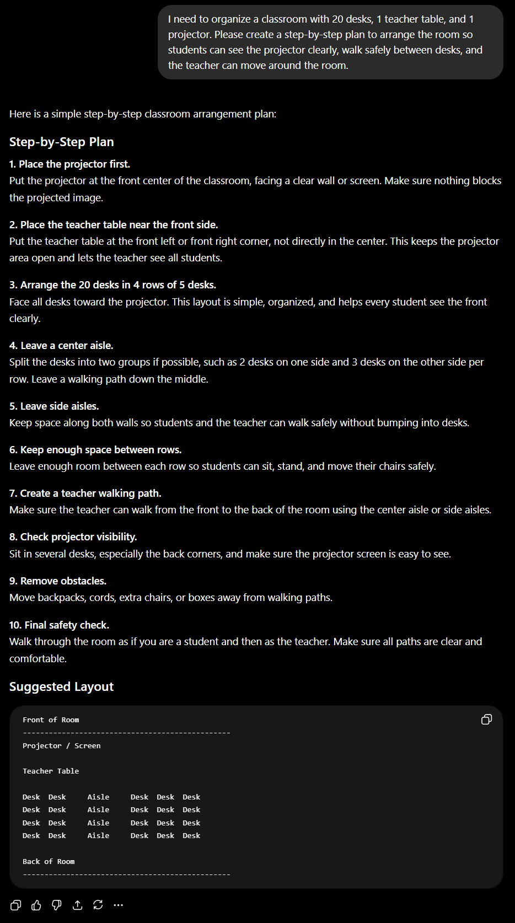
Figure 14 – Initial Step-by-Step Classroom Arrangement Plan Generated by ChatGPT
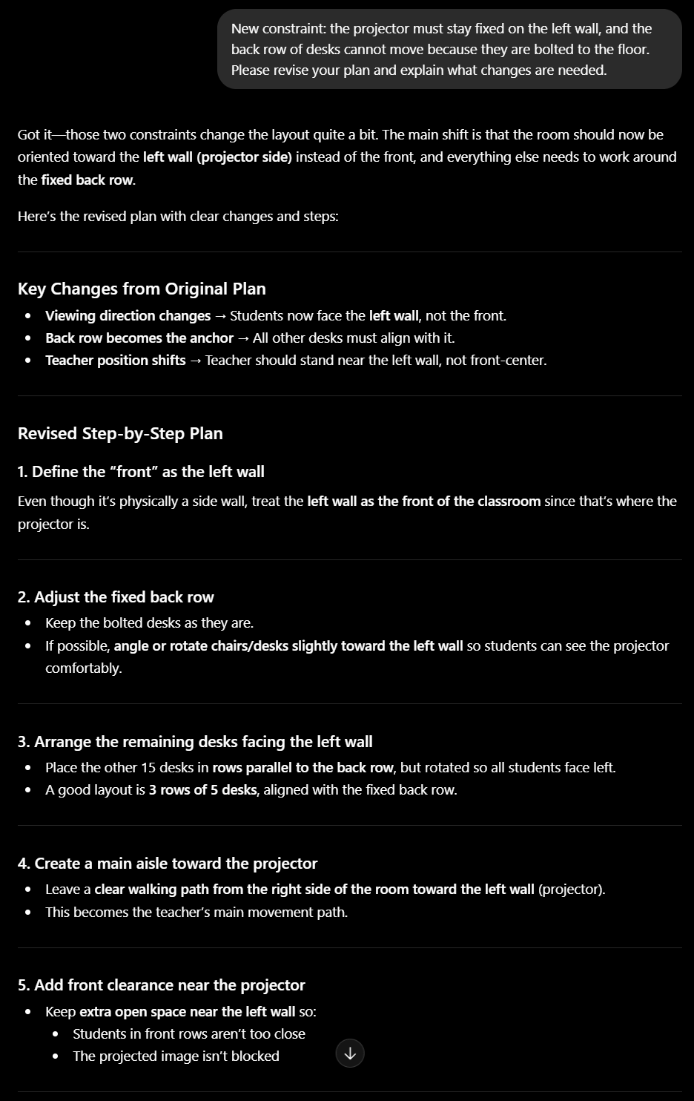
Figure 15 – ChatGPT Revises the Plan After New Physical Constraints (Part 1)
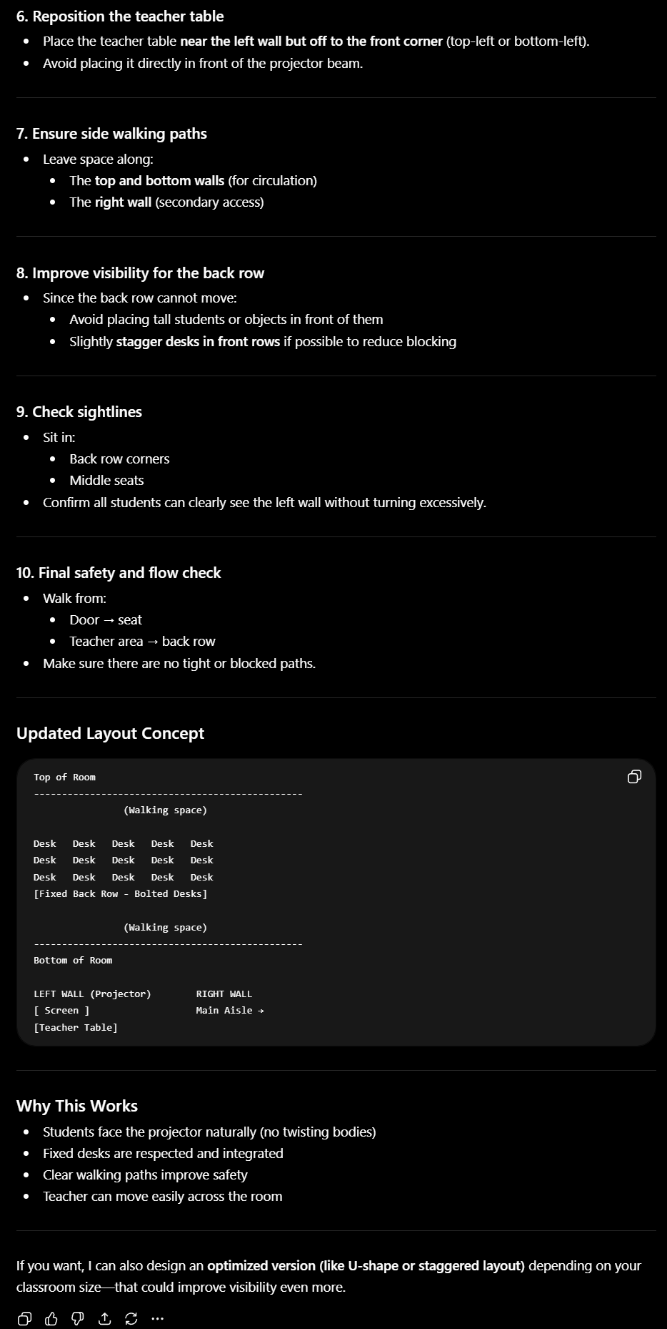
Figure 15 – ChatGPT Revises the Plan After New Physical Constraints (Part 2)
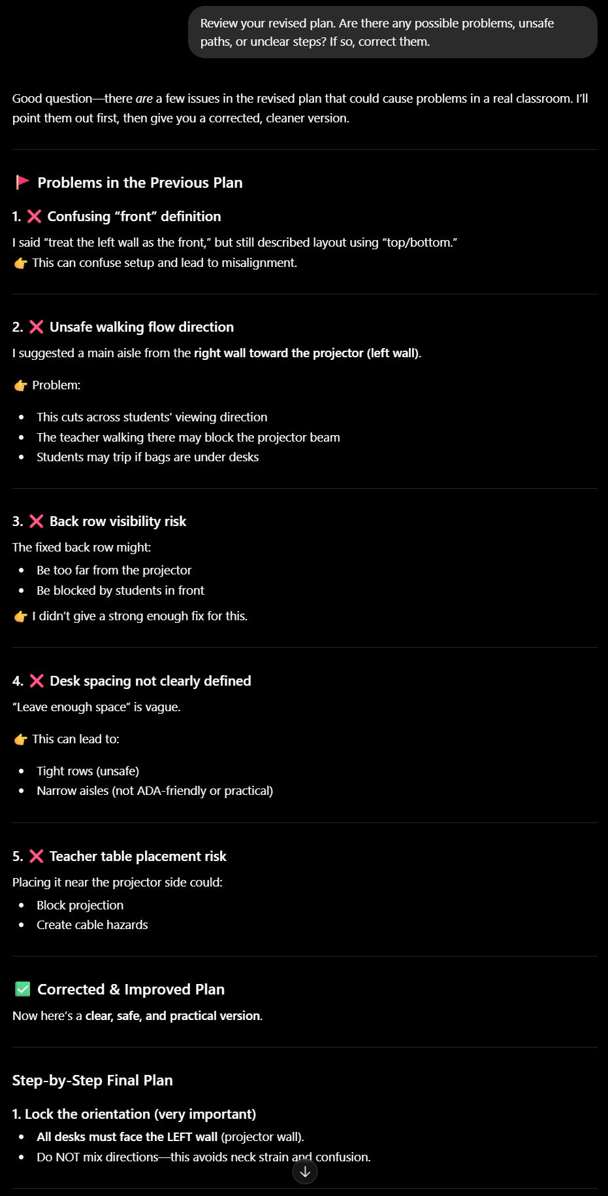
Figure 16 – ChatGPT Identifies Problems and Produces a Corrected Plan (Part 1)
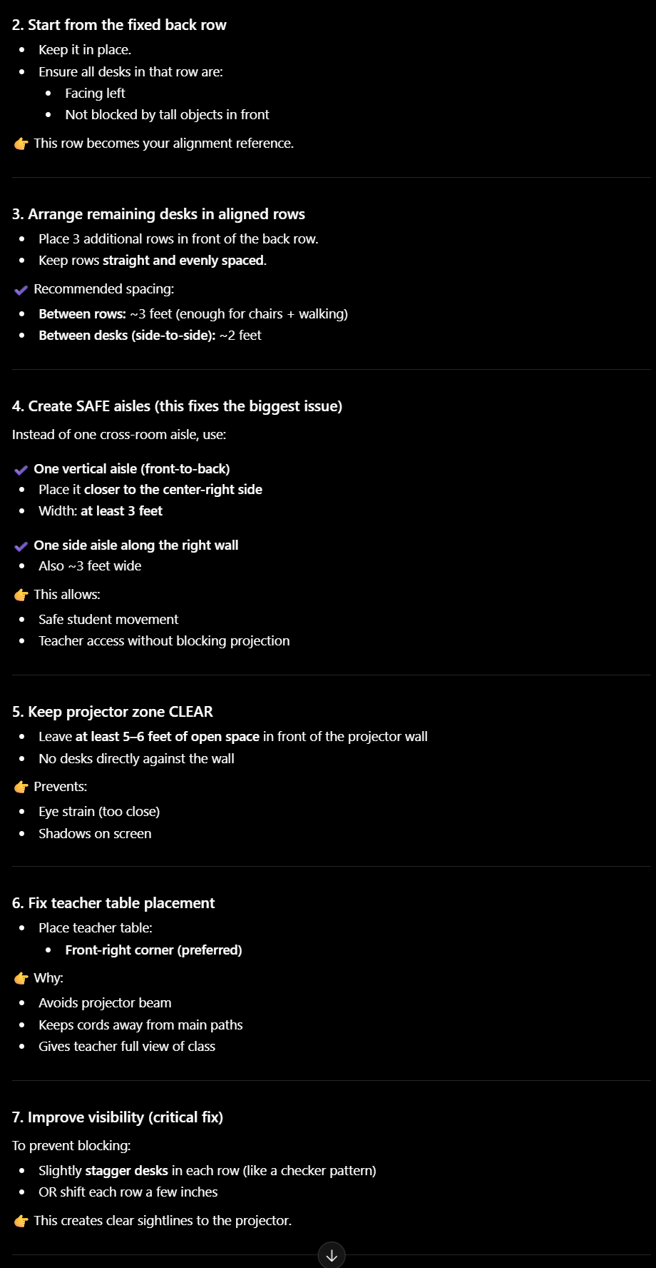
Figure 16 – ChatGPT Identifies Problems and Produces a Corrected Plan (Part 2)
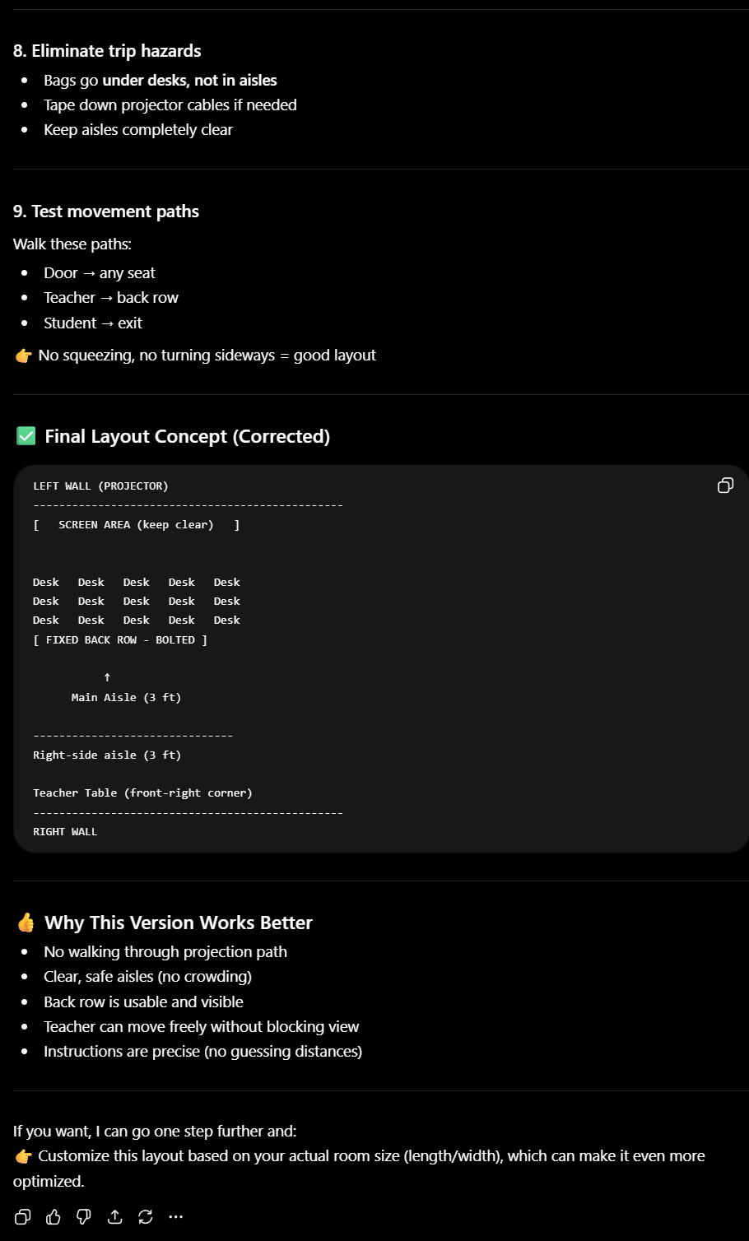
Figure 16 – ChatGPT Identifies Problems and Produces a Corrected Plan (Part 3)
5.5 Analysis
The results suggest that ChatGPT can effectively simulate certain aspects of motor planning, particularly in tasks that involve sequential organization and logical reasoning. The system demonstrated the ability to generate a structured plan, modify that plan in response to constraints, and identify errors in its own output. These behaviors resemble aspects of human motor planning, which involves creating action sequences and adapting them based on changing conditions.
However, there are important differences between ChatGPT’s behavior and human motor systems. In humans, motor planning is closely linked to physical execution and sensory feedback. The brain continuously updates its actions based on real-time information from the body and environment. ChatGPT, in contrast, does not interact with the physical world. Its planning is entirely abstract and based on language rather than real-world experience.
Additionally, human motor systems rely on feedback loops that allow for trial-and-error learning. If a plan does not work in practice, humans can adjust their actions based on direct experience. ChatGPT lacks this capability. While it can revise its plan when prompted, it does not independently test or verify whether the plan would work in a real environment.
The error correction stage highlights both strengths and limitations. ChatGPT was able to identify logical problems in its own plan and propose improvements, which suggests a form of internal consistency checking. However, this process is based on reasoning over text rather than actual environmental feedback or physical constraints.
Overall, ChatGPT demonstrates strong performance in simulating planning and error correction at a conceptual level, but it does not replicate the embodied, feedback-driven nature of human motor systems. Its ability in this domain should be rated as Partial to Strong: it performs well in structured planning tasks, but lacks real-world interaction, sensory feedback, and true motor execution.
Brain vs. AI Scorecard
Dimension | Rating | Module | Evidence Summary
Memory (Working vs. Long-Term) | Partial | Module 04 | ChatGPT retained information within a conversation but failed to recall it across sessions, showing no true long-term memory.
Selective Attention | Strong | Module 07 | ChatGPT successfully filtered irrelevant information and followed key instructions even in noisy and complex prompts.
Emotional Processing | Partial | Module 06 | ChatGPT adjusted tone appropriately for neutral, sarcastic, and frustrated inputs but did not demonstrate real emotional understanding or motivation.
Visual Perception | Partial | Module 03 | ChatGPT accurately described clear images and recognized the duck–rabbit illusion but relied on learned patterns rather than true perceptual processing.
Motor Planning and Error Correction | Partial to Strong | Module 05 | ChatGPT generated structured plans, adapted to constraints, and identified errors, but lacked real-world feedback and physical execution.

Scorecard Analysis
The scorecard reveals that ChatGPT performs strongest in structured cognitive tasks such as selective attention and step-by-step planning, where clear inputs and logical reasoning are required. In these areas, the system can effectively filter information, follow instructions, and organize actions in a way that resembles certain functions of the human brain. However, across all modules, a consistent limitation emerges: ChatGPT relies heavily on pattern recognition and contextual input rather than biologically grounded processes.
In memory, the system demonstrates short-term retention but lacks long-term storage and consolidation, which are essential features of human cognition. In emotional processing, ChatGPT can simulate empathy and tone adjustment, but this behavior is not driven by internal states or motivation. Similarly, in visual perception, the system performs well when recognizing familiar or clear patterns but does not engage in true sensory interpretation or experiential understanding.
The motor planning experiment highlights both strengths and limitations. While ChatGPT can generate and revise complex plans and even identify its own errors, it does so entirely through abstract reasoning rather than physical interaction or feedback from the environment. Unlike the human brain, which continuously adjusts behavior through sensory input and real-world experience, ChatGPT operates only within a static, text-based context.
Overall, the results suggest that ChatGPT is best described as a system that simulates cognitive functions rather than replicating them. It achieves strong performance in structured, language-based tasks but lacks the adaptive, embodied, and experience-driven mechanisms that define human intelligence. This gap between simulation and biological reality represents the most significant difference between artificial intelligence systems and the human brain.
Brain-Inspired Redesign
The results of this audit show that while ChatGPT can simulate several cognitive functions, it lacks the underlying biological mechanisms that make human intelligence adaptive, persistent, and experience-driven. Based on these findings, several improvements can be proposed by drawing inspiration from how the human brain operates. These redesign suggestions focus on memory, attention, emotional processing, perception, and motor planning.
Persistent Memory System Inspired by the Hippocampus
One of the most significant limitations observed in this audit is the absence of long-term memory. ChatGPT was able to retain information within a single conversation but failed to recall it across sessions. In the human brain, the hippocampus plays a critical role in consolidating short-term memories into long-term storage, allowing individuals to retain information over time and across contexts.
To address this limitation, ChatGPT could be redesigned with a persistent memory system that stores important user-specific information and learned patterns across interactions. This system should not simply store all data, but instead prioritize relevant information based on importance, frequency, and context. A selective memory mechanism, similar to human memory consolidation, would allow the system to improve personalization and continuity over time.
Implementing such a system would make ChatGPT more adaptive and consistent, allowing it to build knowledge from past interactions rather than treating each session as independent. This would significantly enhance its ability to simulate human-like learning and memory.
Goal-Directed Attention Mechanism Inspired by the Prefrontal Cortex
The attention experiment showed that ChatGPT can effectively filter information and follow instructions, but it tends to prioritize the most recent or dominant input rather than making goal-driven decisions. In humans, attention is regulated by the prefrontal cortex, which uses internal goals and context to determine what information is most relevant.
To improve this, ChatGPT could incorporate a goal-directed attention mechanism that maintains a stable objective throughout a task. Instead of relying primarily on input order, the system could track the user’s intent and weigh information based on relevance to that goal. This would allow the model to handle conflicting instructions more effectively and avoid being overly influenced by the most recent prompt.
Such a mechanism would improve decision-making consistency and make the system’s behavior more aligned with human cognitive control processes.
Internal State Modeling for Emotional Processing and Motivation
The emotional processing experiment demonstrated that ChatGPT can adjust its tone based on user input, but this behavior is purely simulated and not driven by internal emotional states or motivation. In humans, emotional responses are influenced by systems such as the amygdala and are closely tied to motivation and decision-making.
A possible redesign would involve incorporating a simplified internal state model that tracks interaction context, such as user frustration level or task difficulty. This would not require true emotions but could simulate continuity in emotional responses across interactions. For example, if a user repeatedly expresses frustration, the system could adapt its responses over time rather than treating each message independently.
This approach would create more consistent and context-aware interactions, improving the system’s ability to simulate human-like emotional intelligence and responsiveness.
Multimodal Perception with Contextual Reasoning Inspired by the Visual Cortex
The perception experiment showed that ChatGPT can describe images and recognize known patterns, but it does not truly “see” or interpret visual input in a biologically grounded way. Human perception involves integration of sensory input, spatial awareness, and prior experience through the visual cortex.
To improve this capability, ChatGPT could be enhanced with deeper multimodal perception systems that combine visual input with contextual reasoning. Instead of relying primarily on pattern recognition, the system could incorporate spatial reasoning and uncertainty modeling, allowing it to better handle ambiguous or incomplete images.
For example, when encountering unclear visual input, the system could generate multiple hypotheses and evaluate them rather than immediately selecting a single interpretation. This would more closely resemble how humans process ambiguous visual information.
Feedback-Driven Planning System Inspired by Sensorimotor Loops
The motor planning experiment demonstrated that ChatGPT can generate structured plans, adapt to constraints, and correct errors at a conceptual level. However, it lacks real-world feedback and cannot verify whether its plans would work in practice. In humans, motor systems rely on continuous feedback from sensory inputs to adjust actions in real time.
To address this, ChatGPT could be redesigned to incorporate feedback-driven planning mechanisms. This could involve simulating environmental constraints or integrating external data sources that allow the system to test and refine its plans iteratively. Instead of producing a static plan, the system could generate, evaluate, and adjust actions dynamically.
Such a system would improve the realism and reliability of generated plans, making them more practical and aligned with real-world conditions.
Overall Redesign Summary
These proposed improvements highlight a common theme: the need to move from static, pattern-based responses toward adaptive, context-aware, and feedback-driven systems. The human brain is not simply a pattern recognition engine; it is an integrated system that continuously learns, adapts, and interacts with the environment.
By incorporating mechanisms inspired by memory consolidation, goal-directed attention, emotional state modeling, multimodal perception, and feedback-driven planning, ChatGPT could become more aligned with biological intelligence. While fully replicating the human brain is not currently feasible, these changes would significantly reduce the gap between artificial and human cognition.
Ultimately, the redesign emphasizes that the future of artificial intelligence lies not only in improving performance, but in making systems more adaptive, consistent, and grounded in the principles that govern human intelligence.
Conclusion
This project evaluated ChatGPT through a neuroscience-based framework to determine how closely its behavior aligns with the cognitive functions of the human brain. Across five experiments—memory, attention, emotional processing, perception, and motor planning—the results consistently showed that ChatGPT is capable of simulating many aspects of human cognition, particularly in structured, language-driven tasks. The system demonstrated strong performance in selective attention and planning, and it effectively adapted its responses based on context and input.
However, the findings also revealed fundamental limitations. ChatGPT does not possess long-term memory consolidation, genuine emotional states, real sensory perception, or feedback-driven motor control. Instead, its behavior is primarily driven by pattern recognition and contextual processing rather than biologically grounded mechanisms. As a result, while its outputs may resemble human cognition, the underlying processes are fundamentally different.
Overall, ChatGPT should be understood as a system that simulates intelligence rather than replicates it. This distinction highlights both the strengths and limitations of current artificial intelligence systems and underscores the importance of integrating insights from neuroscience to guide future AI development.

